

DRAMA SAMPLE EXAMINATION

STAGE 3

Section 7 of the New WACE Manual: General Information 2006–2009 outlines the policy on WACE examinations.

Further information about the WACE Examinations policy can be accessed from the Curriculum Council website at http://newwace.curriculum.wa.edu.au/pages/about_wace_manual.asp.

The purpose for providing a sample examination is to provide teachers with an example of how the course will be examined. Further finetuning will be made to this sample in 2008 by the examination panel following consultation with teachers, measurement specialists and advice from the Assessment, Review and Moderation (ARM) panel.

input.doc




Western Australian Certificate of Education, Sample External Examination

Question/Answer Booklet

DRAMA
SAMPLE EXAMINATION
Please place your student identification label in this box
STAGE 3

STUDENT NUMBER - In figures

In words

Time allowed for this paper
Reading time before commencing work: Ten minutes
Working time for paper: Two and a half hours

Material required/recommended for this paper
To be provided by the supervisor
This Question/Answer Booklet
Illustrations Insert for Drama Studies

To be provided by the candidate
Standard items: Pens, pencils, eraser or correction fluid, ruler
Special items: Nil

Important notes to candidates

No other items may be taken into the examination room. It is your responsibility to ensure that you do not have any unauthorised notes or other items of a non-personal nature in the examination room. If you have any unauthorised material with you, hand it to the supervisor before reading any further.

Structure of the paper

SECTION | Format | No. of questions available | No. of questions to be attempted | Marks available | Suggested time (minutes)
ONE  Analysis and interpretation of a drama text | Short responses | 2 | 2 | 20 | 60
TWO  Australian Drama | Essay | 4 | 1 | 15 | 45
THREE  World Drama | Essay | 4 | 1 | 15 | 45
 |  | Total marks |  | 50

This paper is worth 50% of the total marks for the WACE Stage 3 Examination in this subject. The marks available and suggested times are provided to assist your time management. The remaining 50% of marks will come from the practical component of this examination.

Instructions to candidates

Write your answers in the following locations:

Section One: Answer both questions in the spaces provided in this Question/Answer Booklet

Section Two: Write your essay in the BLUE ANSWER BOOKLET

Section Three: Write your essay in the YELLOW ANSWER BOOKLET

Follow the instructions given at the start of each section. Questions may be answered in any order.

You should address the specific requirements of the questions you choose to answer. In your responses you should try to show that you can do the following:

- understand and discuss the use of dramatic forms, conventions and texts
- demonstrate knowledge and understanding of the historical, social and cultural contexts of drama
- understand the relationships between performance theories and styles, texts and contexts
- explore and discuss the structure and performance of drama using appropriate terminology
- analyse and discuss drama and its impact on audiences
- support your points of view with reference to specific examples of drama.

At the end of the examination, check that your Student Identification Label and your Student Number (in figures and words) have been placed in the spaces provided on the front cover of this Question/Answer Booklet.

Section One:
ANALYSIS AND INTERPRETATION OF A DRAMA TEXT [20 marks]

In this section, you must answer both questions on pages 8–12. Study the drama text below to help you shape and direct your answers.

Suggested working time for this section: 60 minutes

Lists, summaries, diagrams, sketches, tables and graphic organisers may be used where appropriate.

NOTE: whilst this extract is from a drama text now featured in the set text list for the Drama course (2008-2010), future external exams will NOT feature extracts from the set text lists as stipulated in the Drama course. This has been included for the purposes of introducing a new text to teachers.

Still Angela—by Jenny Kemp
Still Angela is an unpredictable portrait of a contemporary Australian woman at three ages. On the cusp of her birthday, Angela goes on a real and imagined journey through time: up the garden path of her childhood; into the kitchen with her lover onto a train that travels into the Simpson Desert.
A note on the three Angelas
The play examines Angela during a period of transition. As a theatrical device the character of Angela is played by three actors.
We have within ourselves, at any moment, our past and the potential for our future. It is as if the potential for any of these Angelas is present and possible, at any moment.
It is intended that the audience can interpret this dynamic in a number of ways and that various narratives are possible.
Film, music/sound and choreography should play key roles in building the form of this work.
Section One: Angela Sitting/Memory
In the space there are three lit corridors (about 3.5 metres long and half a metre wide), one behind the other. There is a small unlit corridor between each one. There is one chair somewhere in the corridors. The three adult ANGELAS, JACK, the MOTHER and the FATHER are on stage in the corridors. Throughout this section the characters work within the corridors (sometimes along the unlit corridors). Whenever one changes direction the others also change direction, so at times it is as if the corridors run upstage, and at times across the stage. The characters move within the parameters of stillness to movement, sometimes sitting, in a kind of rhythmic dance or game. The MOTHER and FATHER are present yet more peripheral than the others.
This sequence is Angela’s process of sorting, sifting, remembering. It should depend on a complex pattern of spatial dynamics. Although the scenes between Angela 1 and Jack are realistic, no props are used, and any gestures or actions used by the actors should be minimal, precise yet simplified, they are the essence of something remembered. The internal rhythm of Angela 3 is established here. As she sits (or at times moves) she travels internally, her memories and emotions bounce, jostle and nudge at her for attention. The action should be rhythmic, as if Angela inhabits areas as she gives them focus. Or alternately her thoughts or memories erupt or appear with a volition of their own.
ANGELA has stopped because she cannot go on. Eventually the next action occurs: ‘to go to the desert’.
JACK AND ANGELA IN THE KITCHEN / LOST KEYS
Movement on the corridors begins.
ANGELA 1: [with real urgency as she’s so late] Where’re my keys! I can’t see them anywhere!
JACK gestures that he doesn’t know, she keeps hunting.
S**t! Who left all this stuff here?!
JACK: Actually. You. Tea.
ANGELA 1: Oww! I’ve burnt my tongue!
JACK: Sorry about that.
ANGELA 1 looks at her watch.
ANGELA 1: I’m late! God I’m going to be so late!
JACK stamps on ants, looks under his shoe.
JACK: S**t. Ants.
ANGELA 1: Egh? Oh.
She sees the keys on the floor, grabs them.
Have to go! ‘Bye!
She kisses JACK and runs.
Don’t forget you’re supposed to pick me up after work!
She stops – it is ANGELA 3’s voice which stops her.
TRAVELLING DOWN HER CHILDHOOD GARDEN PATH / THE BACKYARD
ANGELA 3: Don’t step on the lines. Snakes in the concrete.
Pause
Behind me the side gate. To my right the wall of the house. The window. The gully trap. The path …
She stops.
JACK AND ANGELA IN THE KITCHEN / WASHING DISHES
ANGELA 1 is very pre-menstrual. She has dropped something or hurt herself.
ANGELA 1: [exploding] S**t!
JACK: Break something?
ANGELA 1: [irritated] How many times this week have you done the dishes?
JACK: I did them on Sunday.
ANGELA 1: Well it’s Thursday now!
JACK goes to her then he stops.
JACK: You should have said something.
ANGELA 1: I don’t like the feeling in my body.
Pause
JACK: I’m sorry [Trying to lighten things up] I do nice things to your body too.
She grins a little despite herself.
Didn’t we have a nice time last night?
ANGELA 1: It’s not a joke!
JACK: Angel?
Pause
ANGELA 2: I’m not an angel, Jack.
ANGELA SITTING / THE SPIDER
ANGELA 3: The spider is so still it could be dead.
Pause
I’d love a cigarette.
JACK AND ANGELA IN THE KITCHEN / LAMB’S FRY AND BACON
JACK chases ANGELA 1. They dodge each other and giggle. They continue the game throughout the scene
ANGELA 1: You look sweet and smooth, with your whiskers far back inside your skin.
JACK: My bristles hidden, my fur coat combed flat.
ANGELA is humming. She dances with him.
ANGELA 1: [while dancing or dodging with energy] Do you remember when we met Jack?! You cooked me a beautiful dinner!
JACK is still playing.
JACK: Did I?
ANGELA 1: Lamb’s fry and bacon!
JACK: Did you like that?
ANGELA 1: Yes!
JACK: Through your stomach to your heart!
She does a gyrating movement against him.
ANGELA 1: Yes!
ANGELA THE BAT
ANGELA 3: So Angela and the bat what is the connection?
Is Angela’s sitting a blind act?
In Angela a bat?
A creature of the night, of darkness, of stillness?
Has Angela stopped because she was about to crash?
But this does not mean that Angela is not travelling,
Angela is on the hunt for the grit inside her shell,
Angela is aging, she is at a crucial age, travelling through a particular passage.
JACK AND ANGELA IN THE KITCHEN / ANTS
ANGELA is very late for work again.
JACK: Ants! Everywhere! S**t! You left out the lamb.
ANGELA 1: I know, I know.
JACK: All right, I’m just reminding you. Do you know where my singlet is?
ANGELA 1: It’s in a pile on the floor.
JACK: I slept like a log. Am I taking the car today or you?
ANGELA 1: Me!
JACK: Could you give me a lift in?
ANGELA 1: Okay.
She starts to go.
Hurry up!
Pause.

END OF EXCERPT

SUPPORTING IMAGES ON THE NEXT PAGE
Image 1

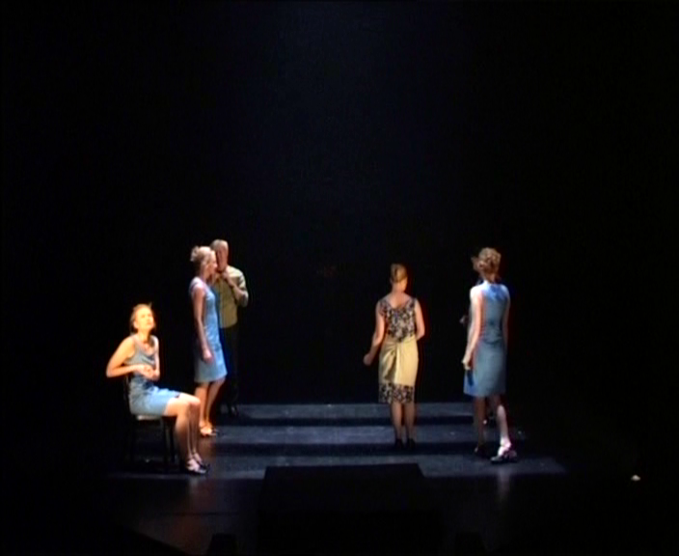

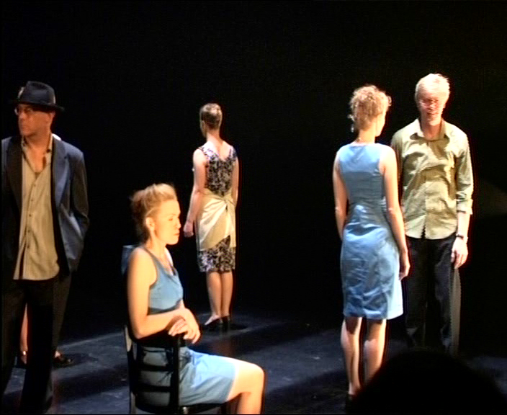
Image 2

Question 1
DESIGNER [10 marks]
As a member of the production team, the Director’s interpretation calls for film, music/sound and choreography to play a key role in the production.

Explain how as ONE designer (that is, as either lighting, sound, costume, makeup, stage or set construction) you could support this approach through your role.

Write your answers across both pages.
WRITE YOUR CHOSEN ROLE:
Design elements

Specific Moments |  | Justify choices

Question 2
ACTOR [10 marks]

As an actor, take on the role of Angela 1 or Jack.

Character: ___________________________________

- Provide a character profile giving evidence from the excerpt.

Profile | Textual evidence

- How would you achieve characterisation?
Vocal communication | Justify choices

Non-verbal communication | Justify choices

Other | Justify choices

END OF SECTION ONE

SECTION TWO: AUSTRALIAN DRAMA [15 marks]

This section contains four questions. Answer ONE question only.

Suggested working time for this section: 45 minutes

Write your answer for Section Two in the BLUE ANSWER BOOKLET. Sketches or diagrams may be included if they are appropriate to your answer.

Answers must relate to one of the following Set Texts that you have studied in class:

Set Texts: Australian Drama
Matt Cameron: Tears from a Glass Eye; Ruby Moon | Hannie Rayson: Hotel Sorrento; Inheritance
Jane Harrison: Rainbow’s End | Stephen Sewell: The Blind Giant is Dancing; Myth, Propaganda and Disaster in Nazi Germany and Contemporary America: A Drama in 30 Scenes
Dorothy Hewett: The Man from Mukinupin; Nowhere
Jenny Kemp: The Black Sequin Dress; Still Angela | Version 1.0: CMI: A Certain Maritime Incident; Wages of Spin.
Justin Monjo and Nick Enright: Cloudstreet
Nick Enright: Man with Five Children | David Williamson: Dead White Males; Face to Face

Your answer to your chosen question (choose one of the four) below should be directly relate to the role or roles specified in the question.

1. Actor and Dramaturge

‘Drama is essentially about the character’s journey and the realisation of that journey in performance is about the choices actors make.’

Identify one of the Set Texts you have studied and discuss one key character journey. Outline the choices you will make as an actor (working with other actors and members of the production team) in the realisation of this journey.

In your response, also consider how dramaturgical research informed your perspective.

Provide references to the Set Text to support your opinions.

OR

2. Designer
Australian plays set up moods and images of particular places that imaginatively communicate across cultural boundaries.

Provide set, sound and lighting designs for one significant scene in your Set Text that draws the attention of the audience to the dominant mood and key imagery in the text.

For each design role, describe and discuss your aims and approach.

Provide references to the Set Text to support your opinions.

OR

3. Director and Manager
As a director and manager of your set text identify how you would create a new approach to enhance the play's themes in performance. Specify when you are adopting the director role and when you are adopting a manager's perspective.
Discuss the scene and the elements that build towards it.

Discuss the scene and the elements that build towards it.

Provide references to the Set Text to support your opinions.

OR

Question 4
Director and publicist

‘Theatre must resonate with its audience.’

(a) As a director, who doesn’t want to mount a conventional production of your set text, provide your vision of how you will stage this text for a 2008 audience. You need to consider design and production choices and specify a stage space.

(b) As a publicist you have to create a 60 second radio advertisement which informs and attracts the audience, keeping with the director’s vision. Provide the script for this advertisement.

Provide references to the Set Text to support your opinions.

END OF SECTION TWO

SECTION THREE: WORLD DRAMA [15 marks]

This section contains four questions. Answer ONE question only.

Suggested working time for this section: 45 minutes.

Write your answer for Section Three in the YELLOW ANSWER BOOKLET. Sketches or diagrams may be included if they are appropriate to your answer.

Answers must relate to one of the following set texts that you have studied in class:

Set Texts: World Drama
Samuel Beckett: Endgame; Waiting for Godot | Harold Pinter
 | Ashes to ashes; The homecoming
Bertolt Brecht: The Caucasian Chalk Circle; Life of Galileo; Threepenny opera | William Shakespeare: Macbeth; The tempest
Caryl Churchill: Mad forest; Top girls | Tom Stoppard: Arcadia; Rosencrantz and Guildenstern are dead
Moises Kaufman and Saul Belber: The Laramie Project | Theatre Workshop: Oh, what a lovely war!
Kuo Pao Kun: Descendants of the eunuch admiral; The spirits play

Your answer to your chosen question (choose one of the four) below should be directly relate to the role or roles specified in the question.

Question 1
Director and dramaturge
‘Theatre is always related to the society out of which it grows – it speaks for the concerns, attitudes and beliefs of the people and the time.’

You have been asked to direct a production of your set text. Identify and discuss the cultural and historical factors on which you base your interpretation of this play.

Outline how you would stage this play for a contemporary Australian audience with consideration of its original context. In your answer consider form and style, set design and blocking.

Provide textual references, including quotes, to justify your opinions.

OR

Question 2
Director and actor
The movement of actors on stage is dramatic and symbolic.

(a) As a director discuss how you would block the action of one key scene or episode of your set text. Outline how you would realise character relationships and symbolic aspects of the play through your blocking. Specify the stage space you will use.

(b) As an actor in this key scene outline your choices with regard to proxemics and other significant non-verbal considerations for your character.

Provide textual references, including quotes, to justify your opinions.

OR

Question 3 Designer
‘Designing for the theatre is not an isolated creative act. Ideas emerge from a detailed study of the text and from research and discussions between members of the creative team.’

With reference to your set text, describe and discuss how you would design the set and lighting to create a fresh approach for a 2008 audience. Identify the form and style of the text and justify the venue selected. Consider the use of the elements of design (line, mass, colour, texture, ornament and balance) in your set design choices. Provide a lighting design which complements the set design.

Provide annotated illustrations and textual references, including quotes to justify your opinions.

OR

Question 4
Director and designer

‘The theatre must give the audience of today a new experience of space.’ James-Roose Evans, director and playwright.’

As director and designer of your set text, explain how you will adapt an outside venue in your school to give meaning for your audience? As a director, consider what meaning you wish to convey. As a designer, consider how you would manipulate two design and production elements to maximise meaning.

Provide annotated illustrations and textual references, including quotes to justify your opinions.

END OF PAPER

THIS SPACE HAS BEEN LEFT BLANK INTENTIONALLY
ACKNOWLEDGEMENTS

PART I

Script extract from Kemp, J. (2005). Still Angela (Act One). Strawberry Hills, NSW: Currency Press, pp. 3–7.

Images from Kemp, J. (2005). Still Angela [Video recording]. Fremantle, WA: Contemporary Arts Media.

Published by the Curriculum Council of Western Australia
27 Walters Drive
OSBORNE PARK WA 6017

